**SAS Learning**

Part I: Getting Started with SAS Programming

Week 1-2 2021.01.24

Access Data—Explore Data—Prepare Data—Analyze and Report on Data—Export Results

On the left hand side of SAS Studio window: The Navigation pane “Libraries—My Libraries” has a expand “SASHELP” consists of a list of sample SAS Table

快捷键：fn+F3: Run. Fn+F4: New SAS Program

All statements must end with a semicolon.

Global Statements can be outside DATA and PROC steps, and they typically defined some option or setting for the SAS session. Global Statements do not need a RUN statement after them.

Add comments for one row or multiple rows:

快捷键：command+/ 可以形成 /* … */

A SAS table is a structured data file that has defined columns and rows. SAS tables have the file extension “.sas7bdat”

The column must have three attributes: name, type and length

Name & Type:

Length:

SAS Table contains two parts: Data and Descriptor

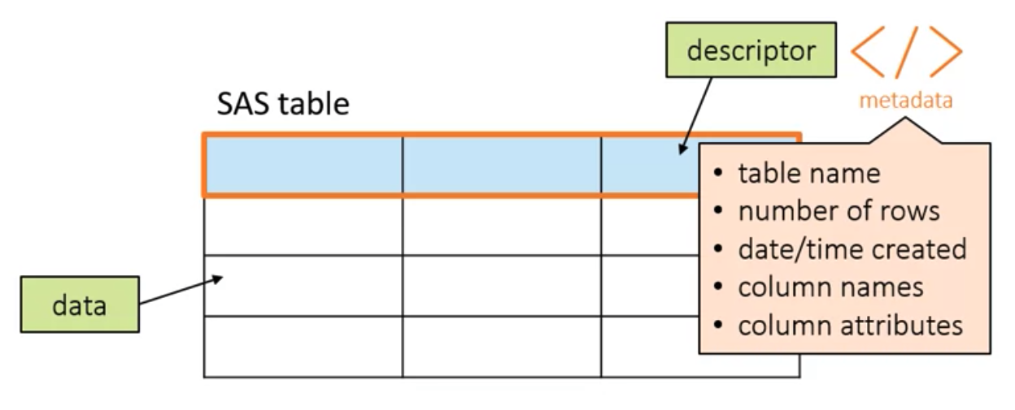

Ways to view the table attributes: (1) Above the table, there is one option for “Table properties” includes the following properties; (2) Write a “PROC CONTENTS” step that creates a report of the descriptor portion of the table.

If there exists missing numeric values in the table, store as a period; if there exists missing character values in the table, stored as a space.

Using a Library to Read SAS Data:

There is a different engine for each type of data SAS can read, including Base for SAS tables, Excel, Teradata, Hadoop, and many others. Base as default that can be omitted.

Noticed that the path must be relative to where SAS is running. If SAS is on your local computer, you can specify a path to a folder on your computer. If SAS is on a remote server, the path or folder must be to a location relative to the server.

By default, a library, or libref, that you define remains active until you delete it or end your SAS session. The libref is simply a pointer or shortcut to your existing data, so although the libref might be deleted when SAS shuts down, your data is not deleted. You'll notice that SAS programs often begin with one or more LIBNAME statements to connect to the various data sources that are used in the code.

/* Create this file as libname.sas */



Automatic SAS Libraries:

Reading other file types by a library:

(1)Excel:

There are two extra statements that are using when read Excel Data: First is OPTIONS STATEMENT—a global statement for specifying system options. Excel doesn't have any rules for column headings, so they can be longer than 32 characters and include spaces or other special symbols. When SAS reads the Excel data, we can force column names to adhere to strict SAS naming conventions by using the VALIDVARNAME=V7 system option.

At the end, clear the temporary table:

Example:

Example:

Importing Data into SAS:

SAS scans the number of rows that you specify to determine type and length of each column in the table.

Example: Importing a Comma-Delimited(CSV) file

Notice: Suppose the original file changes and you want to refresh the SAS table, you should add the REPLACE option.

Example: Importing an Excel file

Notice here, PROC IMPORT step can only read one sheet each time.

There are two ways to read xlsx files, one is above using The XLSX LIBNAME engine reads data directly from the Excel file, so programs that reference the Excel library will always use the current data.  PROC IMPORT creates a copy of the Excel file  that is a snapshot in time until the IMPORT step runs again.

Numeric column with a default length of 8 bytes.

The Sashelp library contains sample and resource tables provided by SAS. The library is automatically available when SAS starts.

A libref must have a length of one to eight characters, and must begin with a letter or underscore. The remaining characters must be letters, numbers, or underscores.